**OUTREACH SCHOOLS EXAMINATION BOARD**

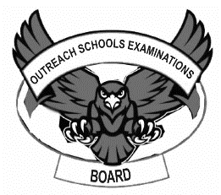 **END OF TERM II EXAMINATION 2024**

**BABY CLASS: (3 – 4 YEARS)**

**LEARNING AREA 1: SOCIAL DEVELOPMENT**

**My name is: ………………………………..………………………….**

**My School is: ……………………………..……….…………………..**

**I am in: ………………………………..…………………………………………..**

1. Oral
2. Where do you go to school?
3. How many days make a week?
4. What is your best colour?
5. Where do you live?
6. How many months make a year?
7. Count 1 – 5
8. What is the name of your class teacher?
9. Who is your best friend?
10. 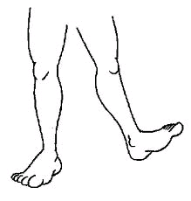What is this?

  

1. Tell these sounds.

a o p s m t i

1. **Write over.**



1. **Match the pictures correctly.**

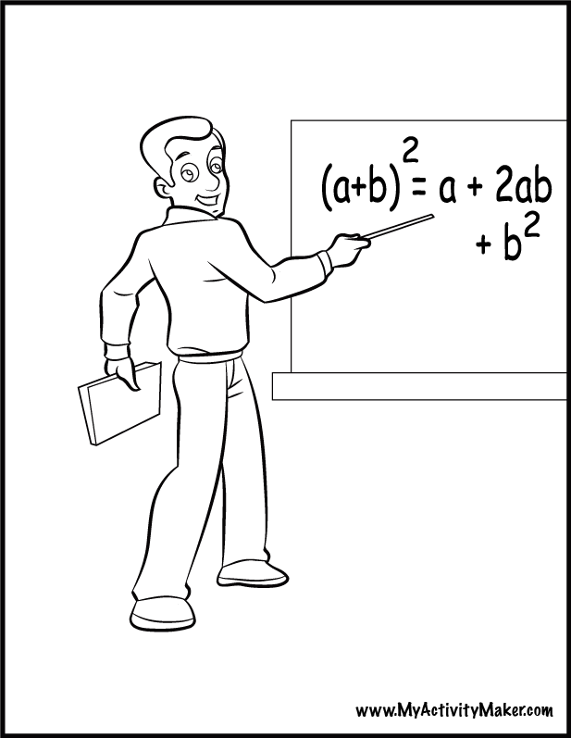





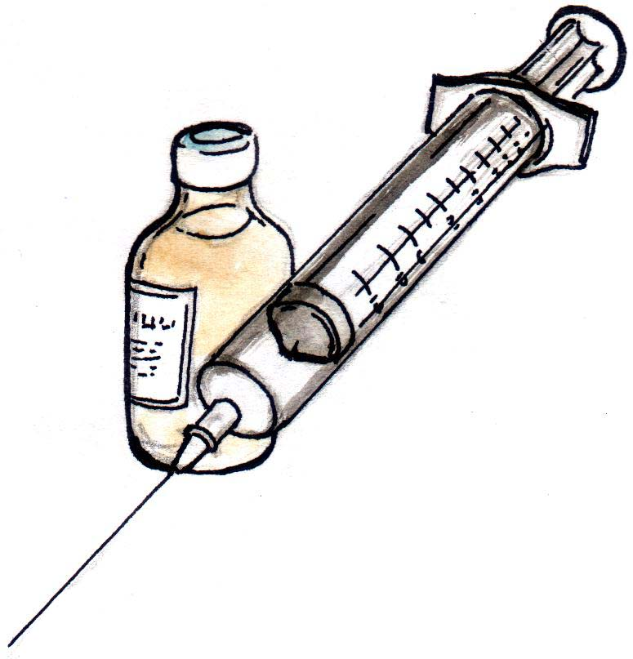

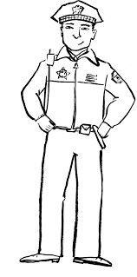

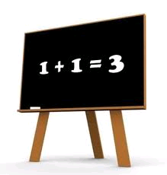

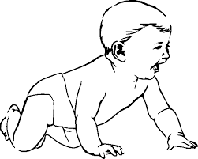

1. **Colour these pictures.**

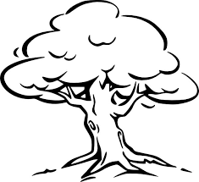



**END**